

ABC Awards Level 2
Motor Vehicle Studies

Underpinning Knowledge Evidence Record

H/601/5555 Knowledge of Removing and Replacing Motorcycle Electrical Units and Components

Learners Name
ABC Awards Registration Number
Centre Name
Assessor 1 Name
Assessor 2 Name

DECLARATION OF AUTHENTICITY

This declaration must be completed and signed by the learner and countersigned by the tutor / assessor and covers all evidence submitted for moderation.

Learner Name
Unique Learner Number (ULN) |  | ABC  Learner Reg. ID
Qualification Title
Centre Name

Learner statement of authenticity

Before signing please read the guidance below.

I confirm, that the attached assignment / portfolio is all my own work and does not include any work completed by anyone other than myself. I have completed the assignment / portfolio in accordance with ABC Awards’ instructions and within the time limits set by my centre.

Signature |  | Date

Centre confirmation of authenticity

On behalf of …………………………………….(insert centre name), I confirm that the above mentioned learner, to the best of my knowledge, is the sole author of the completed assignment / portfolio attached, and the assessments have been completed under the required conditions.

Signed |  | Date
Name
Title

Guidance for Learners

You have been asked to sign this Declaration of Authenticity and place it at the front of your portfolio or course work assessment. It confirms that the work you have submitted for assessment is your own and that you have not copied it from someone else or allowed another learner to copy it from you.

When preparing any course work it is good practice to undertake research using information from published sources. If you quote directly from these sources then this must be indicated in your work by using quotation marks and referencing the document from which the quotation was taken. You must then comment in your own words on any ideas expressed.

Assessors, internal verifiers and ABC Awards’ external moderators and verifiers are subject specialists who can spot the use of published materials that may be passed as your own words or ideas.
If you do copy words from a published source and do not indicate their reference you will be committing plagiarism. This is considered a form of cheating and may result in your assessment being declared void.

Contents

Task No | Title | Assessment Criteria
1 | Basic electrical circuits | 1.1, 1.2, 1.4
2 | Cables and connectors | 1.5
3 | Electrical principles | 1.7, 1.8
4 | Motorcycle circuit protection devices | 1.3
5 | Sensors and actuators | 1.6
6 | Batteries, starting and charging systems. | 2.1, 2.2, 2.3, 2.4
7 | Auxiliary system components | 3.1, 3.2, 3.3, 3.4
8 | Methods of testing | 4.1, 4.2, 4.3, 4.4

Task 1 – Basic electrical circuits | Assessment Criteria 1.1, 1.2, 1.4

Identify and explain the meaning of these electrical wiring diagram symbols and units
Symbol/unit | Meaning and function of component
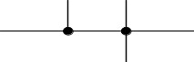
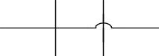
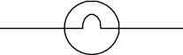
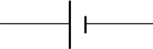
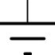
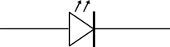
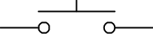
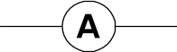
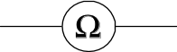
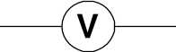

Draw a simple motorcycle starting and charging circuit incorporating electrical symbols and earths

Task 2 – Cables and connectors | Assessment Criteria 1.5

Identify and describe the uses of these electrical connectors
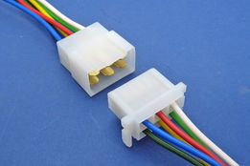
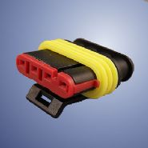
Identify and describe the uses of these electrical wire types
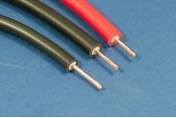
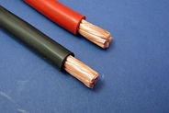
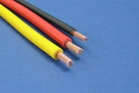

Task 3 – Electrical principles | Assessment Criteria 1.7, 1.8,

Identify 4 electrical units of measurements commonly used in electrical circuits in the table below
Electrical Unit | Explanation of principle

Using Ohms Law calculate the missing values in the table below
Volts | Amps | Resistance
12 | 2
12 |  | 1.5Ω (Ohms)
 | 2.2 | 6Ω (Ohms)

A motorcycle electrical circuit with no faults when tested should read
Volts |  | Amps |  |  | Resistance
12 |  | 4 |  |  | 3
From the readings below identify the type of circuit fault
Volts | Amps |  | Resistance | Type of Circuit fault
12 | 0 |  | 0Ω (Ohms)
5 | 20 |  | 0.2Ω (Ohms)
12 | 0.5 |  | 24Ω (Ohms)

Task 4 – Motorcycle circuit protection devices | Assessment Criteria 1.3

Draw two circuit protection devices below | Describe their operation

Task 5 – Sensors and actuators | Assessment Criteria 1.6

Sensor/actuator | Briefly describe the construction and basic operation of the following sensors/actuators
Cooling sensors
Lambda sensor
Crank shaft position sensor
Throttle position sensor
Exhaust valve actuator

Task 6 – Batteries, starting and charging systems | Assessment 2.1, 2.2, 2.3, 2.4

Identify and explain the construction and operation of these batteries, starting and charging system components and compare against alternatives
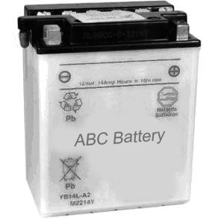 |  | 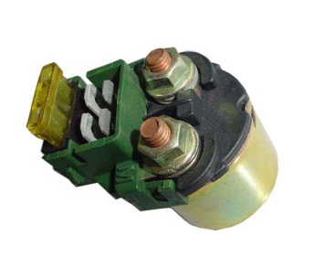
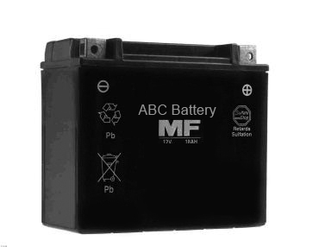 |  | 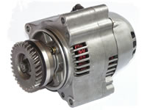
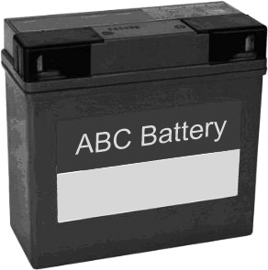 |  | 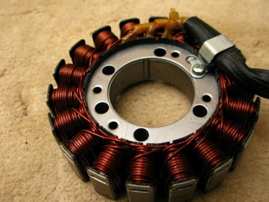
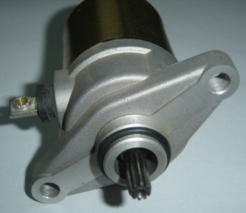 |  | 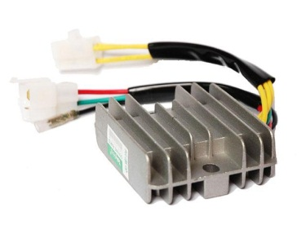

Task 7 – Auxiliary system components | Assessment 3.1, 3.2, 3.3, 3.4

Indentify the construction and operation of auxiliary systems
Name of Auxiliary System | Construction | Operation
1.
2.
3.
4.
For the above systems compare a range of alternative auxiliary system to identify differences in construction and operation

Task 8 – Methods of testing | Assessment 4.1, 4.2, 4.3, 4.4,

Describe how you would safely remove motorcycle electrical and electronic components

Identify 4 items of electrical test equipment, safety checks and how to use the equipment safely in the table below
Name | Safety checks  (where appropriate) | Describe testing method

Identify 4 common faults found in motorcycle electrical systems and components
Fault | Symptom | Cause

Explain how you would test and evaluate the performance of replacement units against manufacturers’ specifications

Unless otherwise stated e.g. for some entry level qualifications, learners can work together but should identify sections which are their own work.

